Bart Bryant-Mole

Durham University

**Googie architecture**

Googie architecture was a vernacular style of architecture that emerged in post-World War II America, primarily in Southern California. Replacing Streamline Moderne as the style of choice for commercial roadside buildings, Googie architecture was characterised by innovative, exuberant designs and attention-grabbing, futuristic forms. Emerging at the peak of America's post-war economic boom, the extravagance of the style symbolised this time of plenty. Though not a cohesive group, certain architects did become associated with Googie architecture. These included Armét and Davis, Douglas Honnold, Martin Stern Jr., and John Lautner. Googie architecture was the subject of much negative criticism by the architectural press of the day, which was still championing the restrained, minimal designs of architects working in the International Style, such as Ludwig Mies van der Rohe. Nevertheless, Googie architecture proved popular with the public. Its mass appeal was, at least in part, due to its frequent stylistic references to both the Automobile Age and the Space Race, which had captured the imagination of America. With its populist aesthetics and eclectic mixing of distinct architectural styles, Googie could be interpreted as a precursor to postmodern architecture.

In 1952, architectural critic Douglas Haskell wrote an article in *House and Home* magazine entitled ‘Googie architecture.’¹ In this article, Haskell identified and christened an entirely new vernacular style of architecture that was emerging in post-World War II America. Most commonly found in Southern California, Googie architecture (later also dubbed Doo-Wop, Populuxe or Coffee Shop Modern architecture) was primarily associated with buildings of a commercial nature, such as diners, drive-ins, restaurants, motels, bowling alleys, gas stations and coffee shops. Indeed, Haskell took the name of the style from that of a coffee shop, *Googie’s*, designed by John Lautner in 1949. Though certain architectural features and motifs appeared across many Googie buildings – for example boomerang shapes, starbursts, and folded eaves – the style can perhaps be more easily identified through a set of more general stylistic traits, such as free and uninhibited compositions, dynamic and eye-catching forms, and multiple and contrasting modern materials. It offered a marked departure from the sleek elegance of the Streamline Moderne style that had been popular in the 1940s.

*Pann’s* (1956), designed by Armét & Davis, exhibits many of the traits and motifs that are typical of Googie architecture. The flat landscape is disrupted by the disjointed bends and folds of an articulated roof, which is pierced by a tapering pylon that stands at a seemingly precarious angle. The roof appears to float in mid-air, as steel supports allow load-bearing walls to be replaced with floor-to-ceiling windows. These supports are largely concealed by tropical plants carefully placed around the exterior, creating a juxtaposition between the synthetic steel and organic foliage.

Googie architects strived to make their designs as futuristic as possible, often taking inspiration from modern technology and science fiction. For example, Martin Stern Jr.’s *Ship’s* (1957), with its neon sign resembling a rocket ship passing behind a planet, referenced the ongoing Space Race.² Paul Williams and the Pereira & Luckman firm went one step further with the *LAX Theme Building* (1961), where a revolving restaurant in the shape of a flying saucer is elevated from the ground by means of a central pillar.

The Automobile Age of the 1950s created the conditions in which Googie architecture could flourish. Roadside establishments were springing up and their proprietors were eager to attract passing motorists. To do so, they employed Googie architects to create car-orientated buildings that would appeal to drivers.³ One such building was Douglas Honnold’s drive-in *Tiny Naylor’s* (1949). Its vast canopy extended over the parked cars and the walkway used by the carhops to serve the customers in their vehicles. Cars were therefore shielded from the elements; whatever the weather, those with convertibles were free to dine with the roof down and customers were able to get out of their cars and socialise.

Prior to Haskell’s article, this emerging style had generally been either ridiculed or ignored by the architectural press. When compared to the minimal, functional architecture of high modernist architects such as van der Rohe, Googie buildings appeared undisciplined or vulgar to many contemporary critics. Even today, the style remains largely unexamined by architectural criticism. An exception is the work of architectural historian Alan Hess, who offers one of the few in-depth studies of Googie architecture. However, the contribution of this style towards the narrative of architecture should not be underestimated. In the concluding paragraphs of his 1952 article, Haskell predicted that Googie would make the general public more receptive to innovative styles of architecture: ‘Googie accustoms the people to expect strangeness, and makes them the readier for those strange things yet to come which will truly make good sense.’ Indeed, with its playful and populist aesthetic, Googie could justifiably be interpreted as a prelude to postmodern architecture.

References

¹ Haskell, D. ‘Googie Architecture’ *House and Home*, February 1952, pp.86-88

² Hess, A. (2004) *Googie Redux: Ultramodern Roadside Architecture*, San Francisco: Chronicle Books

³ Jakle, J.A. (1999) *Fast Food: Roadside Restaurants in the Automobile Age*, Baltimore: John Hopkins University Press

Further reading

Bryant-Mole, B. (2013) *Googie Architecture: A Reflection of Post-War America*, unpublished dissertation, Durham University

Hine, T. (1987) *Populuxe*, London: Bloomsbury

LeMaire, G. (2011) *Googie Architecture: Futurism Through Modernism*, Archdaily (<http://www.archdaily.com/?p=148641>)

Getty Research Institute: Victor Newlove on Googie Architecture (https://www.youtube.com/watch?v=bxQY8b4FGBc)

Witzel, M.K. and Steil, T. (2004) *Americana: Roadside Memories*, Michigan: Lowe & B. Hould Publishers

Visual material

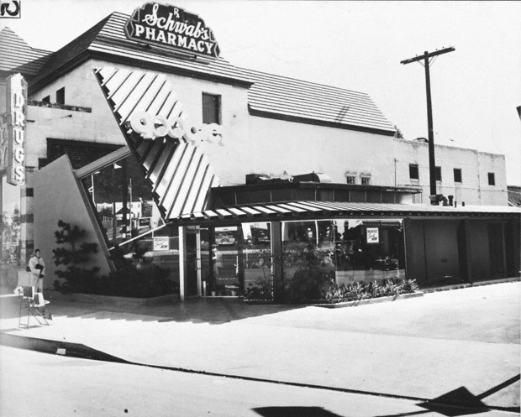

John Lautner, Googie’s Coffee Shop (1949), photo by Julius Shulman

Copyright: Getty Research Institute

<http://blogs.getty.edu/iris/happy-100th-birthday-john-lautner/>

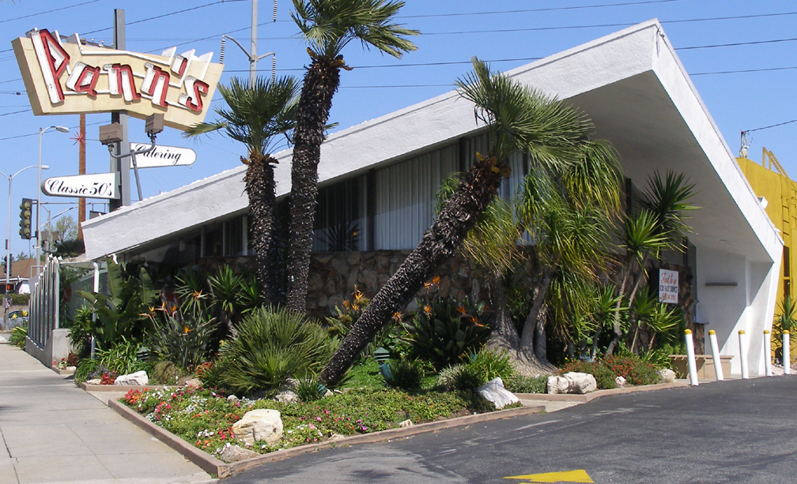

Armét & Davis, Pann’s Coffee Shop (1956), photo by Debra Jane Seltzer

Copyright: Debra Jane Seltzer

<http://www.agilitynut.com/08/4/panns2.jpg>

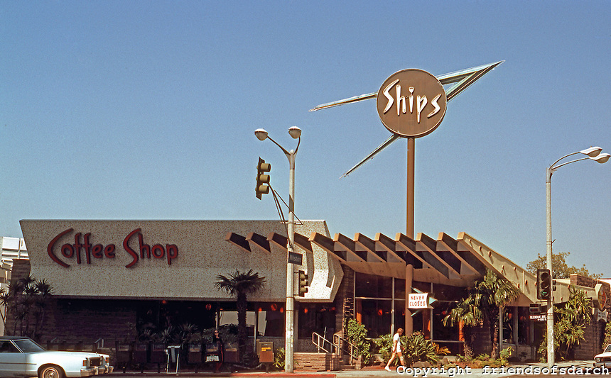

Martin Stern Jr., Ship’s Coffee Shop (1957), photo by Ned Paynter

Copyright: Friends of San Diego Architecture

<http://friendsofsdarch.photoshelter.com/image/I0000cCqY3l3BPKU>

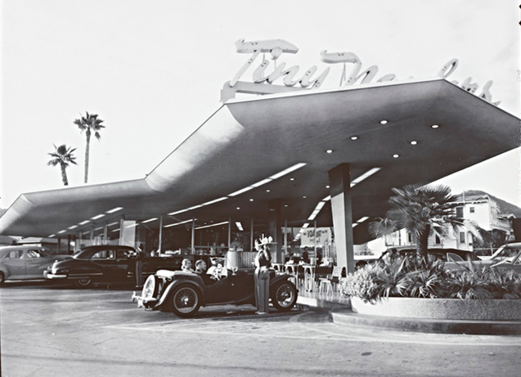

Douglas Honnold, Tiny Naylor’s Diner (1949), photo by Julius Shulman

<http://www.esperdy.net/wp-content/uploads/2011/08/Shulman-Tiny-Naylor.jpg>

Copyright: